UAT-02 – This Week's Decision
Version: 5.1.0 Status: 🟢 Live

Objective
Verify that the application correctly recommends, records, and manages a weekly survivor pick.

What this page does
- Recommends the best survivor pick for the current week.
- Explains why the team is recommended.
- Displays one alternative recommendation.
- Allows the user to record an official pick.
- Locks the official pick until the user chooses to change it.

Test Steps

1. Open the page
Navigate to:
Decision Support → This Week's Decision
Expected
- Current recommendation displayed
- Win probability displayed
- Recommendation explanation displayed
- One alternative recommendation displayed
☐ Pass

2. Record an Official Pick
Select:
Record Official Pick
Confirm the selection.
Expected
- Pick is recorded.
- Official Pick section appears.
- Pick status changes to Locked.
- Recorded date/time is displayed.
☐ Pass

3. Verify Decision Management
After recording a pick verify:
- Official Pick is displayed.
- Recommendation explanation remains visible.
- Alternative recommendation is displayed.
- Compare Strategies button works.
- Weekly Game Analysis button works.
☐ Pass

Expected Outcome
The user should understand:
- Which team is recommended.
- Why it is recommended.
- What alternative exists.
- Which team has been officially recorded.

Definition of Done
☐ Recommendation loads.
☐ Recommendation explanation is understandable.
☐ Official pick records successfully.
☐ Official pick displays correctly.
☐ Alternative recommendation displays.
☐ No errors occur.
Figures
Figure 1. This Week's Decision – Decision Mode (No Official Pick Recorded)
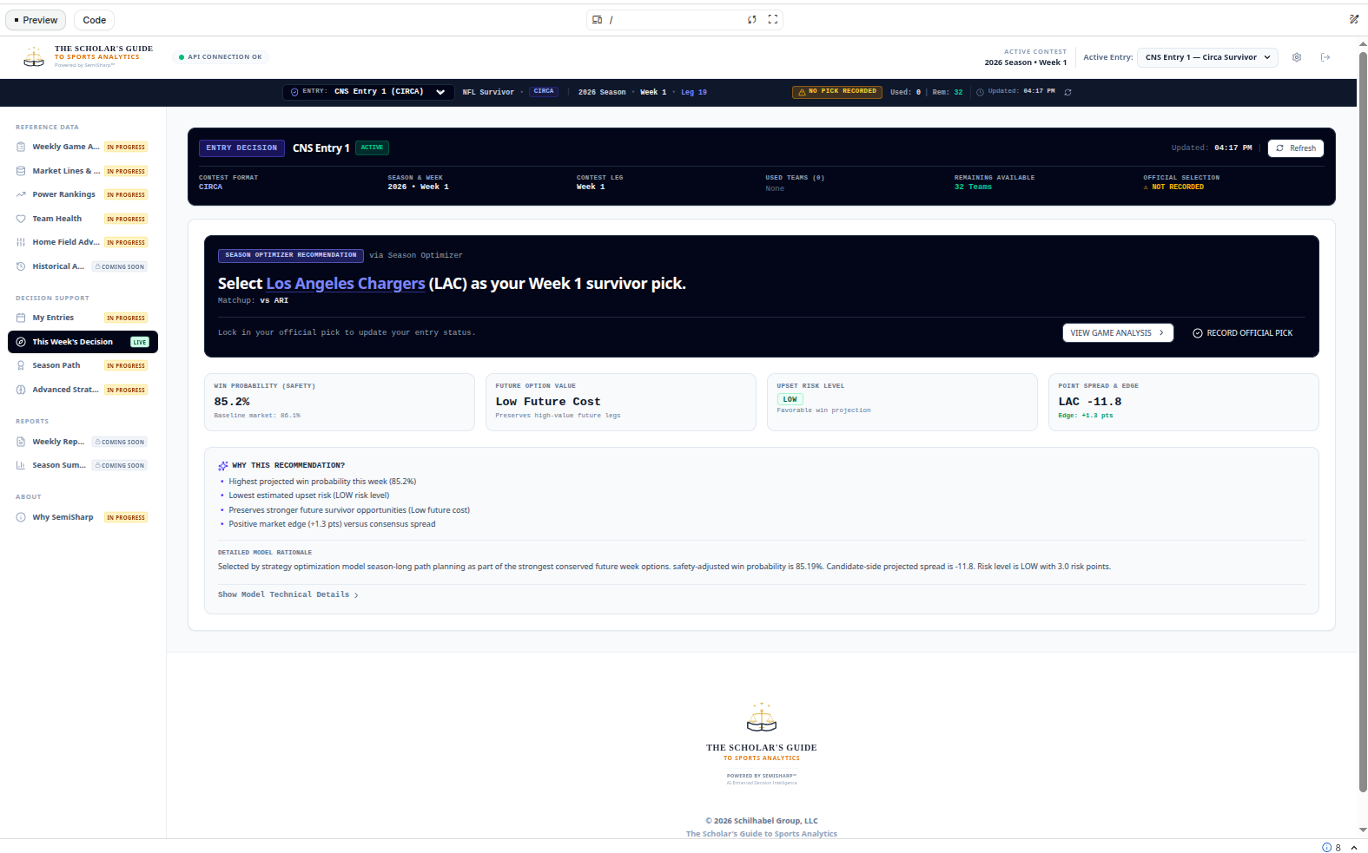
Figure 2. This Week's Decision – Decision Management Mode (Official Pick Recorded)
